Kale Slaw with Peanut Dressing
Serves 6-8
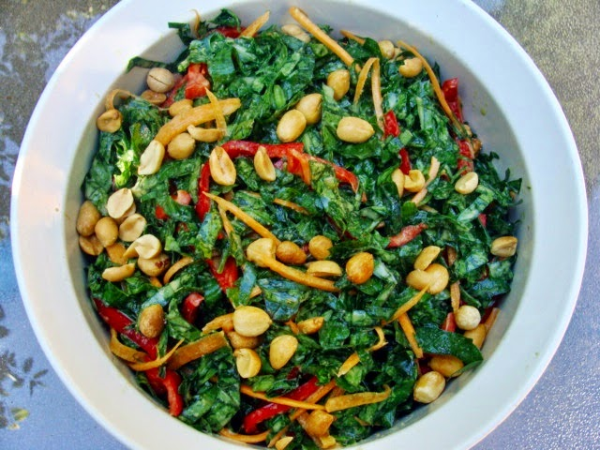
Ingredients
- 2 large bunches curly or lacinato kale, about 2 pounds
- 3 red bell peppers, cleaned and cut into fine strips
- 2 large carrot, peeled
- 1 1/2 cup roasted, salted peanuts, divided
- 2/3 cup vegetable oil
- 6 T cider vinegar
- 2 T packed light brown sugar
- 1 t coarse salt
- Pinch red pepper flakes (optional)
Fold each leaf of kale in half lengthwise and slice out the center rib. Discard ribs. Roll a stack of the leaves up and slice in half lengthwise, then crosswise into very fine ribbons. (placing in food processor works well and is much easier and quicker). You will have 10 to 12 cups of finely chopped kale in the end. Wash and rinse thoroughly in a salad spinner.
Toss the kale with the sliced bell peppers. Slice the carrot very tin, either by creating curls with a pepper, or by running the halved carrot lengthwise down a mandolin. Toss with the kale, red pepper, and 1 cup of the peanuts.
In a chopper or small food processor, briefly puree the remaining ½ cup peanuts, oil, vinegar, sugar, salt, and pepper flakes. Pulse it just a few times; the peanuts should be partially pureed, but with some nibs and nubs still left in the dressing. (The texture difference between the whole peanuts, ground peanuts, and pureed peanuts in the sauce is one of the things that makes this slaw so wonderful).
Toss the dressing with the slaw and let it sit for at least a few minutes before serving.
Per 1/8 of recipe:
Calories: 350
Fat: 30 g
Protein: 10 g
Carbohydrates: 18 g
Fiber: 6 g
Sodium: 430 mg

